Management of Pandemic in Saudi Arabia
As the economy is shut down, the government in Saudi Arabia ensured the citizens met their needs. In accordance with Al-Jadaan, the Finance Minister in Saudi Arabia employed to adopt three resolutions in addressing the pandemic: Fiscal consolidation, removal of subsidies, and increased taxes and fees. The finance minister claimed that the country is facing a global crisis, even with the provided financial reserves and positions and the government debts, which is relatively low.
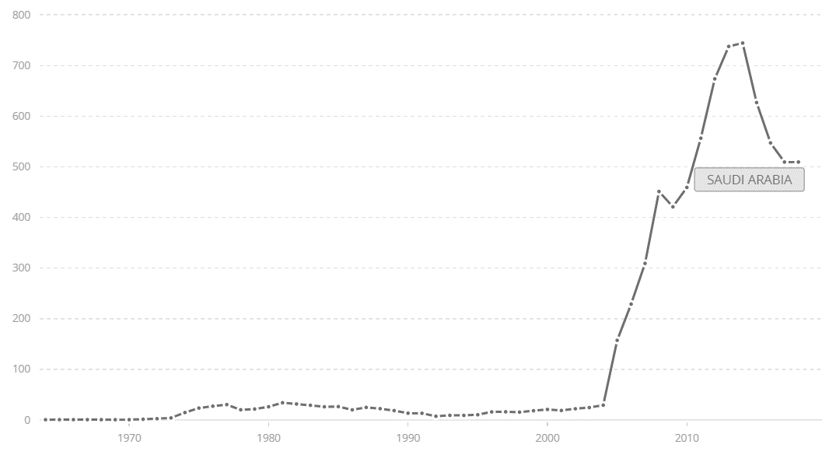

The fig shows the Total reserves in Saudi Arabia by $Billion
Al-Jadaan affirmed that the expenditure challenge is associated with an increase in health bill costs. The current expenditure is 80 percent more, and it is challenging to lower. The greatest challenge is the Fiscal sustainability for the short and medium-term, and the ultimate impacts rely on the crisis duration. One of the primary challenges facing the country is handling the economic crisis and implementing economic rationalization policies to reduce the expenditure and diversity of the income sources.
The impact on the Oil sector
The pandemic has adversely affected the oil prices to drop due to the decrease in crude demand. OPEC+ has a significant role in reducing the country's loss from the oil prices by making negotiations with the OPEC members.

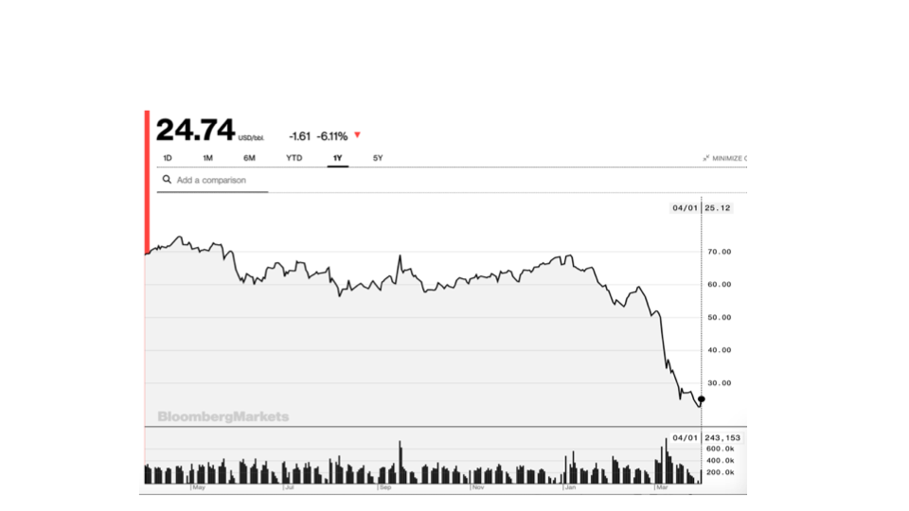

https://www.arabnews.com/node/1669141/business-economy
https://www.arabnews.com/node/1669141/business-economy
https://data.worldbank.org/indicator/FI.RES.TOTL.CD?contextual=aggregate&end=2018&locations=SA&start=1964&view=chart&year_high_desc=true
https://www.arabnews.com/node/1669141/business-economy
https://www.arabnews.com/node/1669141/business-economy

